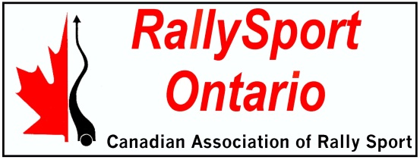
RSO AFFILIATED CLUB
PROXY FORM FOR
2022 ANNUAL GENERAL MEETING
OF RALLYSPORT ONTARIO

Each Club, in order to vote, must elect a member-in-good-standing to act for it by means of a written proxy. This individual must have been a registered member of an RSO-affiliated club in 2022. Please complete the blank form below and send it to the person of your choice by email.

E-mailed proxies must be received by the Secretary before 12 noon on Saturday, April 22nd 2023, to be valid.

RallySport Ontario Annual General Meeting PROXY

______________________________(Club Name), a 2022 RSO Affiliated Club,

hereby appoints and authorizes ______________________________________________

to vote on our behalf at the RallySport Ontario Annual General Meeting to be held virtually on Saturday, April 22, 2023, and any adjournment thereof.

Signed 1._______________________________________________________________
2. ______________________________________________________________
(Must be signed by 2 members of the Club executive, -E-mail identification is acceptable)

Printed Name 1.__________________________________________________________
2. _________________________________________________________

Date _________________________________________________________________

